Functions, Objects, Events – Exercises
Exercises and homework assignments for “Introduction to Programming with AI” course at SoftUni.
Judge submission link: https://alpha.judge.softuni.org/contests/exercises-functions-objects-events/5276.

Create HTML Page
Write a function to print given text as HTML, enclosed in given tag, defaulting to “div”.
Input | Output
console.log(printAsHTML("Hello")); | <div>hello</div>
console.log(printAsHTML("HTML paragraph", "p")); | <p>HTML paragraph</p>
Using the first function, write another function to format title + text as HTML using a <div> with <h1> and <p> inside, like in the example below.

Input and Output
Input | console.log(text2HtmlSnippet("JavaScript", "JS is a modern language."));
Output | <div><h1>JavaScript</h1><p> JS is a modern language.</p></div>

Hints
First, create a folder to keep all your code from this exercise and open it in Visual Studio Code. Give it a reasonable name, e.g. “Functions-Objects-Events”:
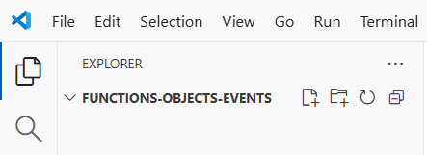
Create a new JS file, which will hold your code. Give it a reasonable name, e.g. “html-snippet.js”:
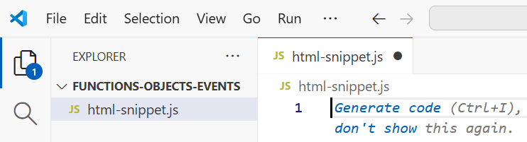
Now, define the first function printAsHTML(text, tag). This is a sample implementation:
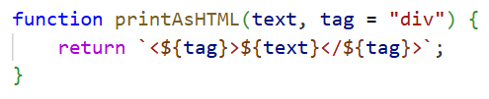
Next, define the second function printHTMLSnippet(title, text).
Important: insert the first function inside the second, as inner function. Otherwise SoftUni judge will be unable to evaluate your solution. This is a sample implementation:
This is a sample implementation:
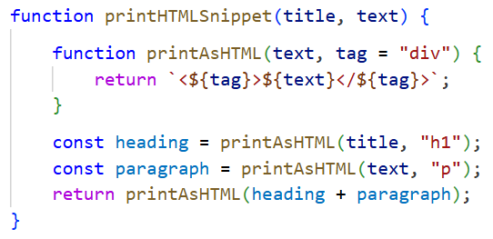

Judge Submission
Submit your code to the judge: https://alpha.judge.softuni.org/contests/exercises-functions-objects-events/5276.
Note: you can submit to the judge only a single JS function. In case you have several functions, move some of them as inner functions, and finally submit only one function, holding the others.

Visualize with HTML
Create a HTML page to visualize the function printHTMLSnippet(title, text): enter a title and text, invoke the function and visualize its output as text and as rendered HTML.
Use a simple prompt in GitHub Copilot:
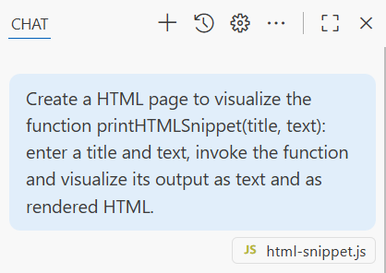
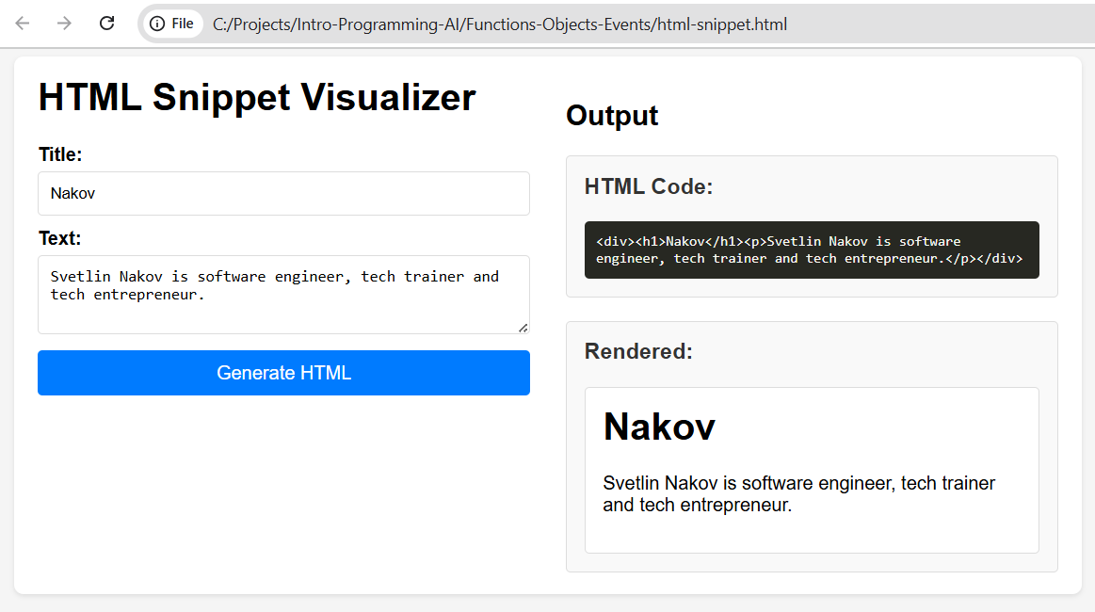

Fibonacci Numbers
In math, Fibonacci numbers are defined as follows:
- fib(0) = 1
- fib(1) = 1
- fib(n) = fib(n-1) + fib(n-2)
Write a recursive function to calculate the Fibonacci number for given n.
Input | Output
fibonacci(5) | 8
fibonacci(0) | 1
fibonacci(15) | 987

Input and Output
Write a JS function to print the Fibonacci number for given input n in the below format.
Input | Output
printFibonacci(5) | Fib(5) = 8
printFibonacci(0) | Fib(0) = 1
printFibonacci(15) | Fib(15) = 987

Hints
First, implement the function fibonacci(n). Then, implement a second function printFibonacci(n) to print the output in the requested format.

Straightforward Implementation
Follow the recursive definition and implement the function as code. Sample implementation:
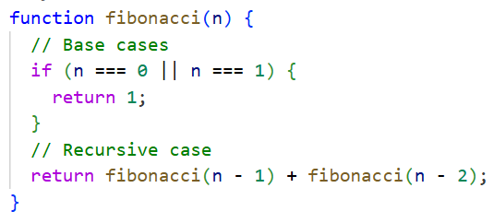

Performance Test
Now test the function for bigger input, e.g. n = 40, or n = 45 or n = 50. You will see that the computation is too slow:
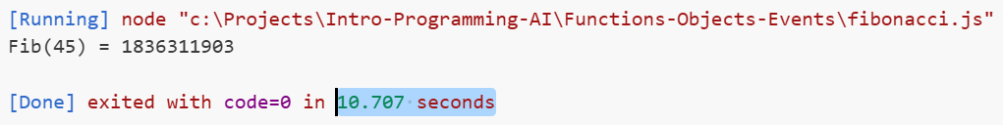
Now ask Copilot to explain why this computation is so slow (e.g. for n = 45) and to implement a fix.
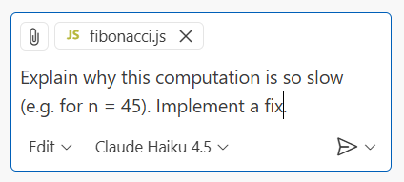
The computation is slow because the implemented recursive approach recalculates the same Fibonacci values many, many times. For example, fibonacci(45) calls fibonacci(44) and fibonacci(43), but fibonacci(44) also calls fibonacci(43) again, creating exponential redundant calculations.
Copilot will (most probably) implement a fix, based on remembering all calculated values in array to avoid redundant re-calculations. This might be too complex, so you ask Copilot to rewrite the code without recursion:
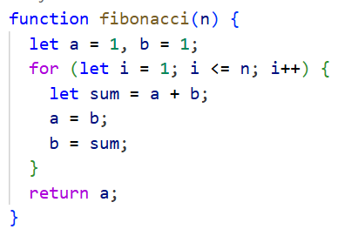
Now your code will run fast for numbers up to 100.

Test with Large Inputs
Now, let's test the above code with larger input values, e.g. 100, 200, 500, …. Looks like the output is incorrect for n=200, or at least is not fully correct:
The reason is that standard numbers in JavaScript overflow. The above result is an approximation, not the exact Fibonacci number.

Implementing BigInt Arithmetic
In JavaScript we have a built-in arithmetic with big integers, based on the BigInt data type. These numbers may hold thousands of digits and don't overflow easily.
You can ask Copilot to fix the arithmetic overflow problem for big inputs, e.g. fibonacci(200). It will make small changes to use BigInt numbers like "1n":
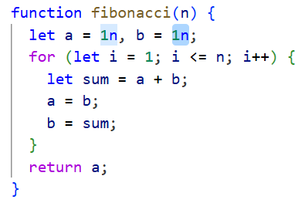

Judge Submission
Note: you can submit to the judge only a single JS function. In case you have several functions, move some of them as inner functions, and finally submit only one function, holding the others.
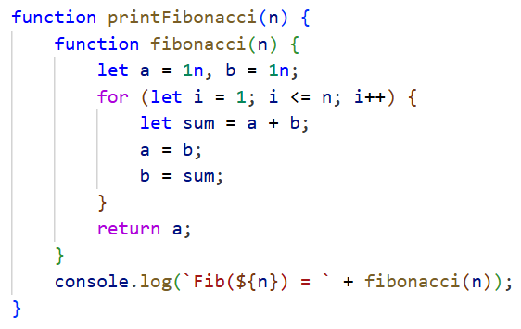
Submit your code to the judge: https://alpha.judge.softuni.org/contests/exercises-functions-objects-events/5276.

Sequence of Operations
Write a JS function to execute a sequence of operations. Take as input a start value and several operations:
- double doubles the current value
- +1 increments the current value by 1
- -1 decrements the current value by 1
- print prints the current value
- stop stops executing the sequence of operations (ignore all further operations)
- any other operation print "invalid operation"

Input and Output
Input | processOperations(  20,  "+1",  "double",  "print"  ); | Comments:  Start from value = 20  Increment value = 21  Double value = 42  Print the current value 42  No more operations stop
Output | 42
Input | processOperations(  5,  "+1",  "double",  "print",  "-1",  "-1",  "clear",  "print",  "double",  "stop",  "+1",  "print"  ); | Comments:  Start from value = 5  Increment value = 6  Double value = 12  Print the current value 12  Decrement value = 11  Decrement value = 10  Invalid operation print "invalid operation"  Print the current value 10  Double value = 20  Stop stop executing further operations  This operation is ignored  This operation is ignored
Output | 12  invalid operation  10

Hints
Use variable number of arguments for the function definition:
function processOperations(startValue, ...operations) { … }
Iterate over the operations using for-of loop and execute them, using a chain of if-else statements.

Filter Numbers
Write a function, which takes several numbers as input and returns all numbers matching these criteria:
- sum of digits = 10
- contains digit 5
- have at least 3 digits
Define the above criteria as predicates (Boolean functions). Define a combined predicate that checks all the others at the same time. Use these predicates to filter the input numbers and print all matching numbers on the console.

Input and Output
Input | filterNumbers(253, 75, -415, 198, 532, 38);
Output | 253  -415  532

Hints
First, define the predicate functions:
- let sumOfDigitsIs10 = (num) => { … }
- let containsDigit5 = (num) => { … }
- let hasAtLeast3Digits = (num) => { … }
- let combinedFilters = (num) => sumOfDigitsIs10(num) && containsDigit5(num) && hasAtLeast3Digits(num);
After that define the filtering function with variable number of input arguments:
- function filterNumbers(...nums) { … }
Iterate over the input numbers and print the ones that match the combined filter.
Ensure that all predicates are defined inside the main function, as inner functions. SoftUni judge accepts a single function and cannot process multiple functions, submitted for evaluation.

Extract Sentences
Write a JS function to extract all sentences from a text. The function should take as input a text and a callback function, scan the text letter by letter, separate the sentences and call the callback for each sentence found. Assume that sentences always end with some of the chars: ".", "!" or "?" and the input text consists of sentences only. Trim the sentences before calling the callback (remove any whitespace at their start and at their end).
Function | splitSentences("I am the first sentence. Am I the second sentence? I am the third sentence!", processSentence);
Action | processSentence("I am the first sentence.")  processSentence("Am I the second sentence?")  processSentence("I am the third sentence!")

Hints
Use for-of loop to scan the input text letter by letter and append the coming letters until you find a sentence separator character. Then call the callback to process the current sentence and start a new sentence.
Sample implementation of the above idea:
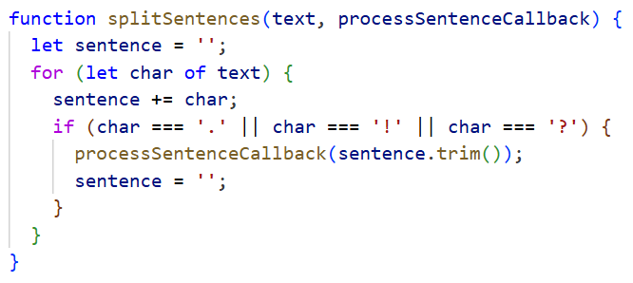

Print Objects
Write a JS function which takes as input an object in the following structure:
{name, address: {town, country}}
Return the data from the object in the following format:
I am Maria from Plovdiv, Bulgaria.

Input and Output
Input | console.log(printPersonInfo({name:"Maria", address: {town:"Plovdiv", country:"Bulgaria}}));
Output | I am Maria from Plovdiv, Bulgaria.

Hints
Use the following function definition with destructured object as input:
function printPersonInfo({name, address: {town, country}}) { … }

Nearest Point
Write a JS function, which takes a location {locX, locY} on the coordinate plate and several points {x, y} and returns the point, which stays closest to the given location. If several points are at the same minimal distance, print the first of them. Calculate the distance using the standard Euclidean distance between the points.

Input and Output
Input | console.log(nearestPoint({locX:10, locY:20}, {x:25, y:30}, {x:-5, y:20}, {x:70, y:-10}, {x:0, y:50}));
Output | { x: -5, y: 20 }

Hints
Use this function definition:
function nearestPoint({locX, locY}, ...points) { … }
Enumerate all points using a for-of loop and remember the nearest point. Calculate the distance between points using the standard Euclidean distance formula:
Math.sqrt((point.x - locX)**2 + (point.y - locY)**2)

Visualization as HTML
Create a HTML page to visualize the location and the points on the coordinate plate. Click on the coordinate plate to add the initial location. Then click several times to add the points. Add them on the coordinate plate, and in a form with text fields. Draw the location and the nearest point with different colors, than all other points.
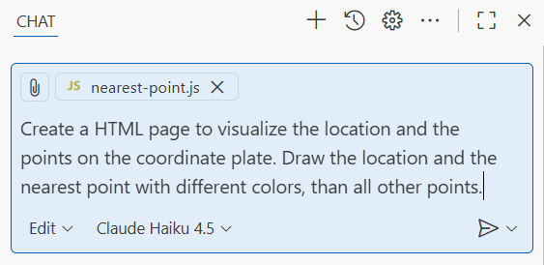
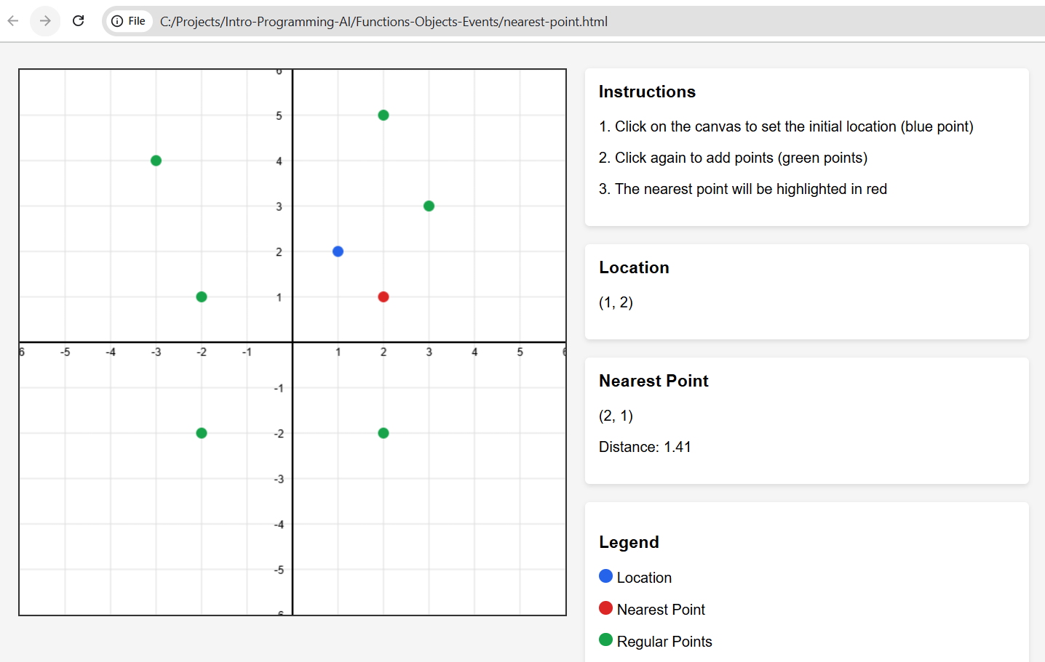

Geo Surface Area
You are given a sequence of geo locations in format {latitude, longitude}, which define a certain plot on the geographic map. Write a JS function to calculate the surface area of the plot in square meters (m²).
- Keep it simple. For simplicity, assume that the Earth is a perfect sphere.
- The input is a simple polygon (non-self-intersecting).
- You can use the formula for area of a spherical polygon.

Input and Output
Input | let area = calculateGeoArea(  { latitude: 42.635912, longitude: 23.369442 },  { latitude: 42.635917, longitude: 23.369905 },  { latitude: 42.636574, longitude: 23.369877 }  );  console.log(`Area: ${area.toFixed(2)} m²`);
Output | Area: 1384.10 m²

Hints
This problem is extremely complex, and you will be unable to solve it correctly without AI (unless you are a strong mathematician or you do solid research upfront).
Use an AI prompt to explain what you want to achieve and let the AI write the code and conduct the mathematical calculations for you!
Note that different AI engines may produce different outputs, which are less or more correct. Some will consider that the Earth is not a perfect sphere. Some will use different formulas. Some will work in degrees or radians; others will try to calculate directly into square meters. Differences could be small or larger, so it is hard to define strictly the expected output.

Judge Submission
This problem will not be evaluated in the judge system, because different formulas and approaches to calculate the geo surface give different outputs and it is hard to be strict.

Visualization as HTML
Using the function calculateGeoArea(...coordinates) create a HTML page, holding an interactive map. Create a polygon on the map by sequentially selecting points. Finally, press a button to calculate the area of the polygon in square meters.
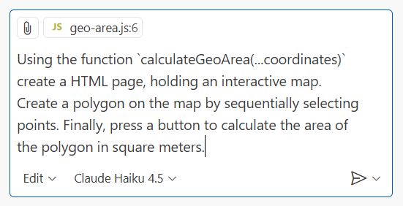

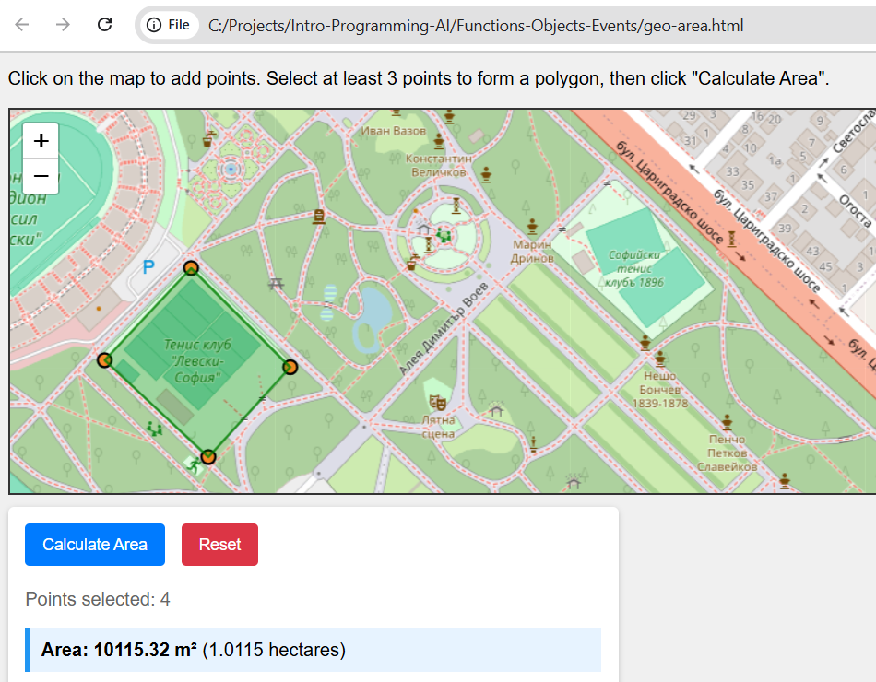

Class Hierarchy
Using JavaScript classes, define the following classes:

Class Color
Class Color, holding:
- Properties red, green and blue values of the color
- Method toString() – returns the color in the standard format #RRGGBB (hex values)

Class Figure
Class Figure (abstract, intended to be used through subclasses only), which holds:
- x, y – location of the figure
- Method move(dX, dY) – moves the figure with given distances
- Method resetPosition() – sets the location to {0, 0}
- Method area() – calculates the area of the figure, abstract (should be implemented in subclasses)
- Method perimeter() – calculates the area of the figure, abstract (should be implemented in subclasses)

Class ColorfulFigure
Class ColorfulFigure (abstract, intended to be used through subclasses only), inherits from Figure, which holds:
- color – color of the figure

Class Square
Class Square, inherits from Figure, which holds:
- width – size of the square side
- Method toString() – returns the square in this format:
  - Square({10, 35}, width = 10)
- Methods area(), perimeter() – implement them to work correctly

Class Rectangle
Class Rectangle, inherits from Figure, which holds:
- width, height – size of the rectangle sides
- Method toString() – returns the square in this format:
  - Rectangle({-10, 20}, size = 20 x 15)
- Methods area(), perimeter() – implement them to work correctly

Class Circle
Class Circle, inherits from Figure, which holds:
- rаdius – the circle radius
- Method toString() – returns the square in this format:
  - Circle({20, -10}, rаdius = 15)
- Methods area(), perimeter() – implement them to work correctly

Class Annulus
Class Annulus, inherits from Figure, which holds:
- outterRаdius, innerRadius – two radiuses (external and internal)
- Method toString() – returns the square in this format:
  - Annulus({20, -10}, ext. rаdius = 15, int. rаdius = 5)
- Methods area(), perimeter() – implement them to work correctly

Classes with Colors
Create classes ColorfulSquare, ColorfulRectangle, ColorfulCircle, ColorfulAnnulus, which inherit from ColorfulFigure. Their toString() method should return their representation like in these examples:
- Square({10, 35}, width = 10, color = #FF7A1E)
- Rectangle({-10, 20}, size = 20 x 15, color = #7FAAE8)
- Circle({20, -10}, rаdius = 15, color = #00EE00)
- Annulus({20, -10}, ext. rаdius = 15, int. rаdius = 5, color = #EE3333)

Creating and Using Figures
Create, initialize and print several figures of different kinds, calculate and print their surface areas and perimeters.

Visualization as HTML
Visualize as HTML several colorful figures, using a Copilot prompt.

HTML Page with Events Handlers
Create an HTML page, holding two text fields: start size and end size.
Add a button [Print text] and handle its "onclick" event with a JavaScript function.
Add a <div> element to hold the output.
When the button is clicked:
- Check the input range: 0 < start size < end size < 100. If the range is invalid, print "Invalid range".
- Otherwise, print the following texts for the specified range (e.g. 5…9):
  - <div style="font-size=5pt">Size 5</div>
  - <div style="font-size=6pt">Size 6</div>
  - <div style="font-size=7pt">Size 7</div>
  - <div style="font-size=8pt">Size 8</div>
  - <div style="font-size=9pt">Size 9</div>
Add CSS styles (with a Copilot prompt) to make the HTML page look better visually.

